**Day 2**

**Experiment 6:-**

**Aim:-**

To Demonstrate virtualization by Installing Type-2 Hypervisor in your device, create and configure VM image with a Host Operating system (Either Windows/Linux).

**STEP 1**: DOWLOAD VMWARE WORKSTATION AND INSTALLED AS TYPE 2 HYPERVISOR

**STEP2:** DOWLOAD UBUNTU OR TINY OS AS ISO IMAGE FILE

**STEP 3:** IN VMWARE WORKSTATION->CREATE NEW VM

**STEP 4:** DO THE BASIC CONFIGURATION SETTINGS.

**STEP 5**: CREATED TINYOS VIRTUAL MACHINE

**STEP 6**: LAUNCH THE VM

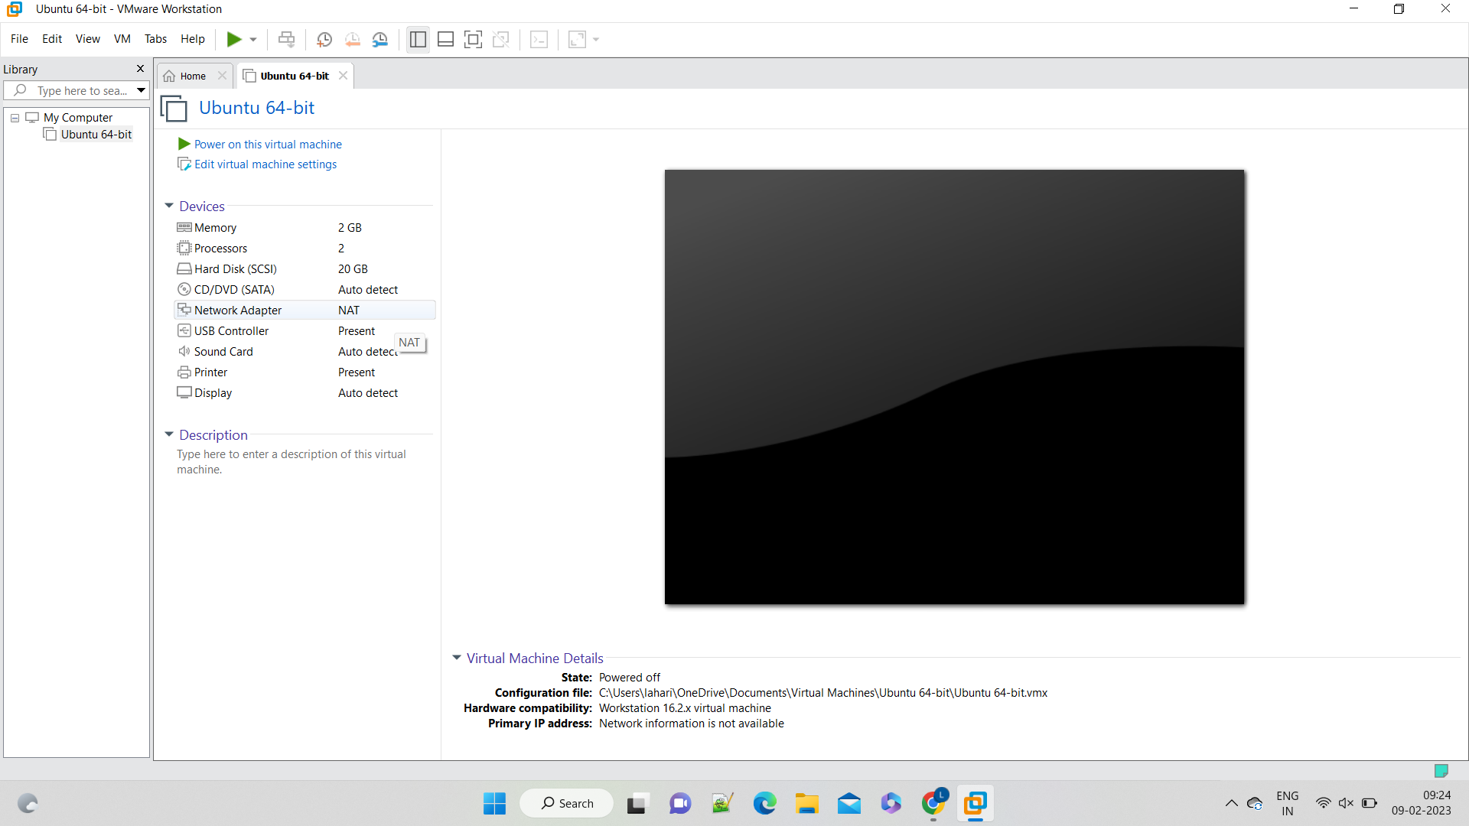

**Experiment 7:-**

**Aim:-**

TO CREATE A VIRTUAL MACHINE WITH 1 VCPU, 2GB RAM AND 15GB STORAGE DISK USING A TYPE 2 VIRTUALIZATION SOFTWARE

**STEP 1:** GOTO VMWARE WORKSTATION

**STEP2:** RIGHT CLICK THE VM AND GOTO THE SETTINGS

**STEP 3:** ADD HARDWARE WIZARD AND SELECT SCSI AND CLICK NEXT

**STEP 4:** CREATE NEW VIRTUAL DISK

**STEP 5:** SELCT THE DISK SIZE AS 2.0. AND SELCT SPLIT VIRTUAL DISK INTO MULTIFILES.

**STEP 6:** GIVE NAME AND CLICK THE FINISH

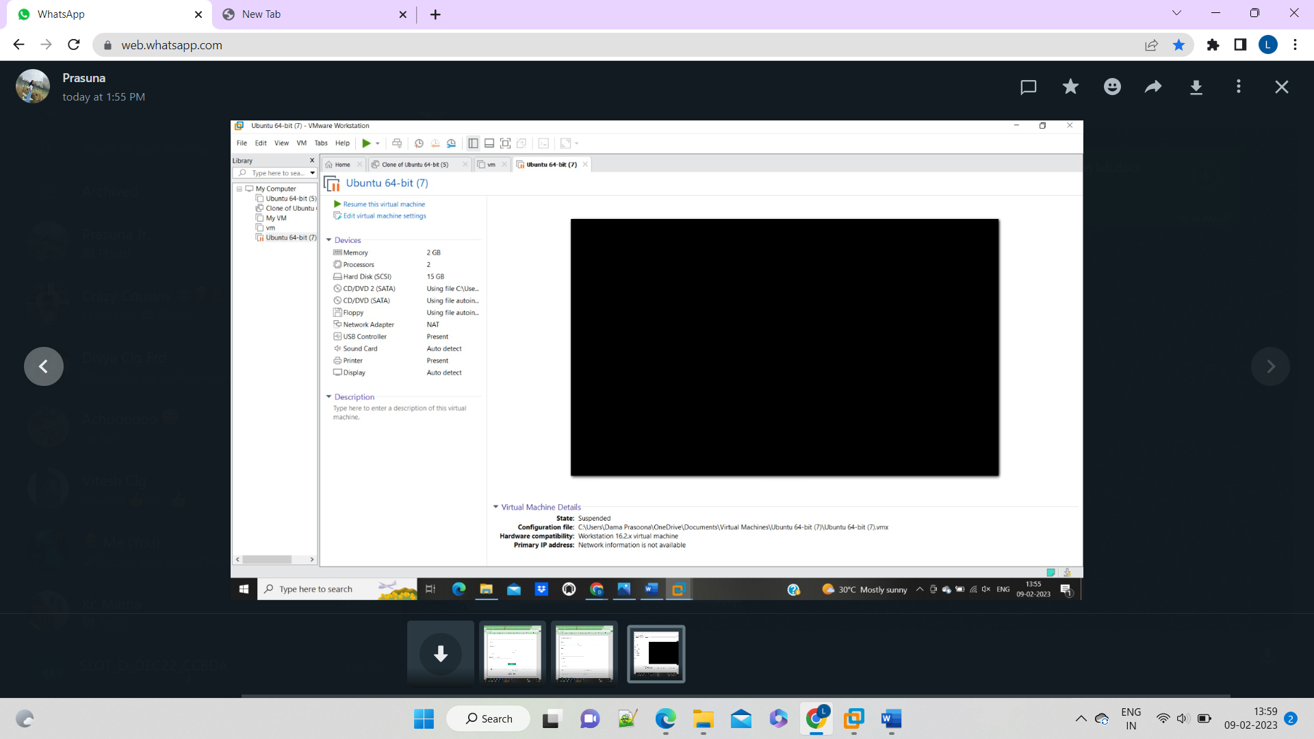

**Experiment 8:-**

**Aim:-**

TO CREATE A VIRTUAL HARD DISK AND ALLOCATE THE STORAGE USING VM WARE WORKSTATION

**STEP 1:** GOTO VMWARE WORKSTATION

**STEP2:** RIGHT CLICK THE VM AND GOTO THE SETTINGS

**STEP 3:** ADD HARDWARE WIZARD AND SELECT SCSI AND CLICK NEXT

**STEP 4:** CREATE NEW VIRTUAL DISK

**STEP 5:** SELCT THE DISK SIZE AS 2.0. AND SELCT SPLIT VIRTUAL DISK INTO MULTIFILES.

**STEP 6:** GIVE NAME AND CLICK THE FINISH

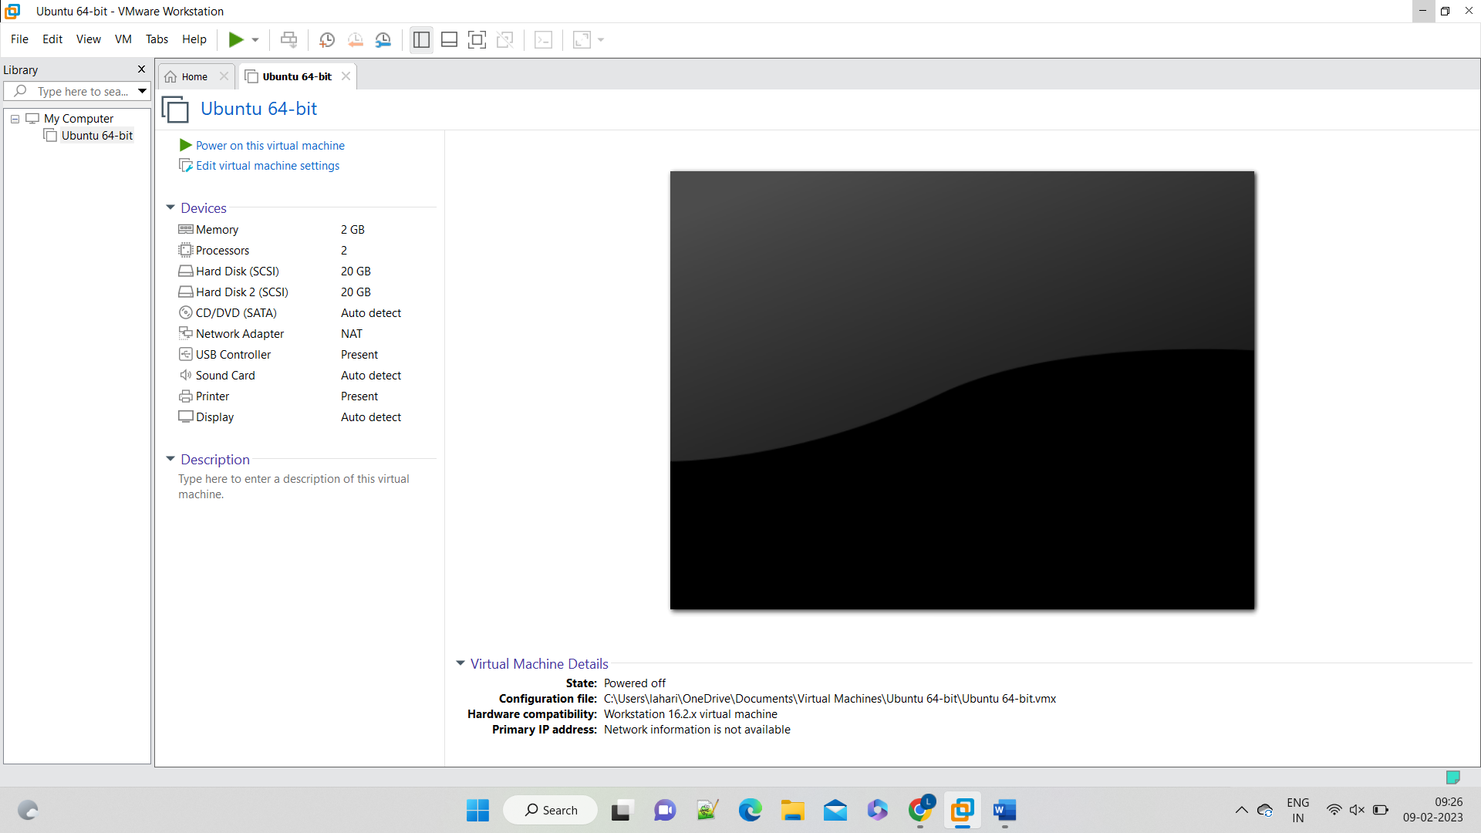

**Experiment 9:-**

**Aim:-**

CREATE A SNAPSHOT AND CLONING OF A VM AND TEST IT BY LOADING THE PREVIOUS VERSION/CLONED VM.

STEP 1: GOTO VMWARE WORKSTATION

STEP 2: CREATE FILES ON DESKTOP

STEP 2: CLICK ON VM AND SELECTS SNAPSHOT-> TAKE SNAPSHOT.

STEP 4: SNAPSHOT IS BEING DONE

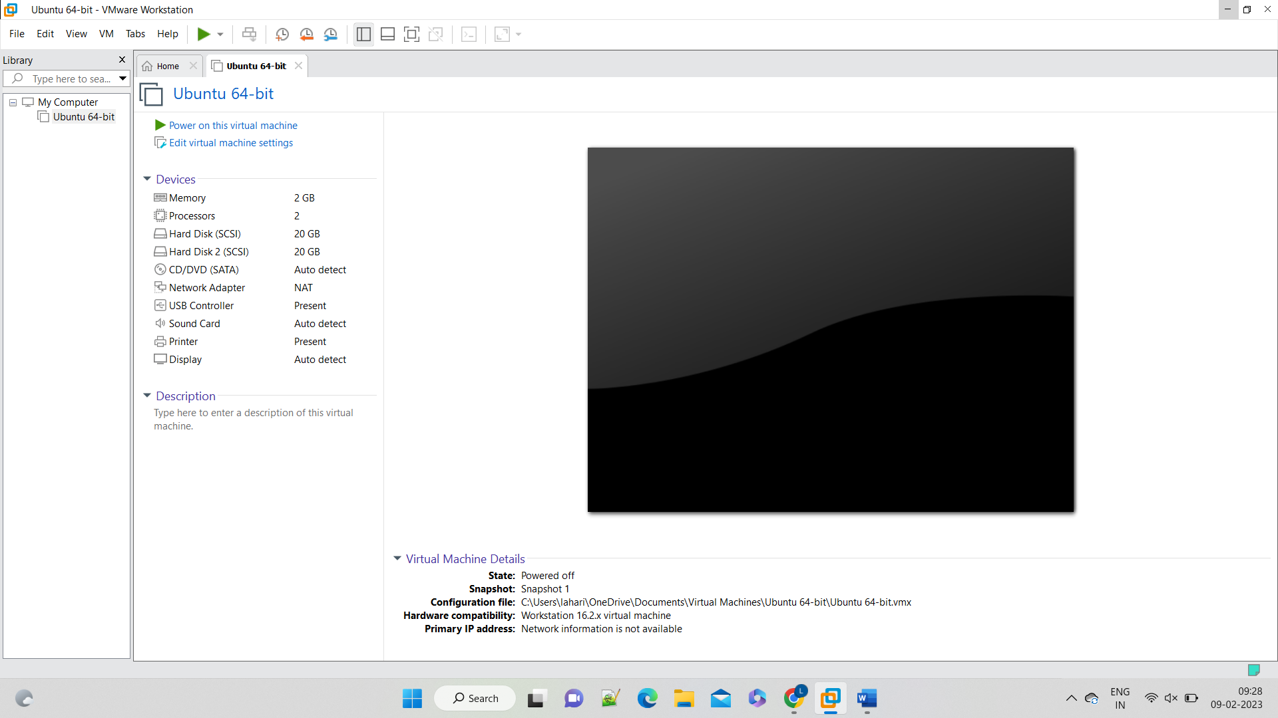

**Experiment 10:-**

**Aim:-**

CREATE A CLONING OF A VM AND TEST IT BY LOADING THE PREVIOUS VERSION/CLONED VM

**STEP 1**: GO TO VM AND GOTO MANAGE AND CLICK CLONE

**STEP 2**: CLICK CLONE

**STEP 3**: SELECT THE FULL CLONE

**STEP 4**: AFTER CLONE AGAIN OR VM IS OPENED

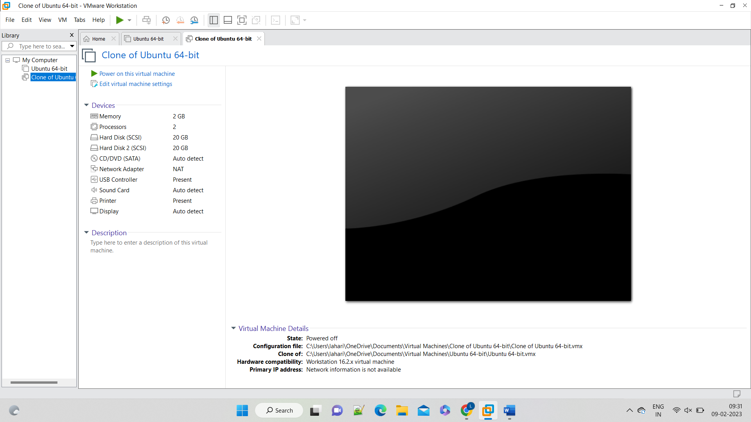

**Experiment 11:-**

**Aim:-**

Change Hardware compatibility of a VM (Either by clone/create new one) which is already created and configured.

**STEP 1**: GO TO VM AND GOTO MANAGE

**STEP 2**: CLICK ON CHANGE HARDWARE COMPATIBILITY

**STEP 3**: CHOOSE THE HARDWARE COMPATIBILITY

**STEP 4**: NAME THE CLONE

**STEP 5**:THE HARDWARE COMPATIBILITY IS CHANGE SUCCESSFULLY

